Neuron Sandbox Problem #1: Can you make a peanut butter and jelly sandwich? You need both peanut butter and jelly.
INPUTS |  | Compute weighted input 1: | Compute weighted input 2: | Activation: | Do we want the activation to be greater than the threshold?  This answer should be based on the desired output. | Determine the threshold:  What decimal number is greater than your Ns but less than your Ys? | Is activation greater than threshold?  If the answer doesn’t match the 1 or 0 in the desired output, change your threshold | Desired Output
Input₁  0 - Don’t have  1 - Have | Input₂  0 - Don’t have  1 - Have | W₁ = 1  Input₁ x W₁ = __ | W₂ = 1  Input₂ x W₂ = __ | Sum of weighted Inputs 1 & 2 | (Y or N) | Threshold | Activation > Threshold  Write 0 for no and 1 for yes. | 0 - no  1 - yes
___ | __ | __ x 1 = __ | __ x 1 = __ | __ | __ | __ | __ | __
__ | __ | __ x 1 =___ | __ x 1 = __ | __ | __ | __ | __ | __
__ | __ | __ x 1 =___ | __ x 1 =___ | __ | __ | __ | __ | __
__ | __ | __ x 1 =___ | __ x 1 =___ | __ | __ | __ | __ | __
B |  | C |  | D | E | F | G | A

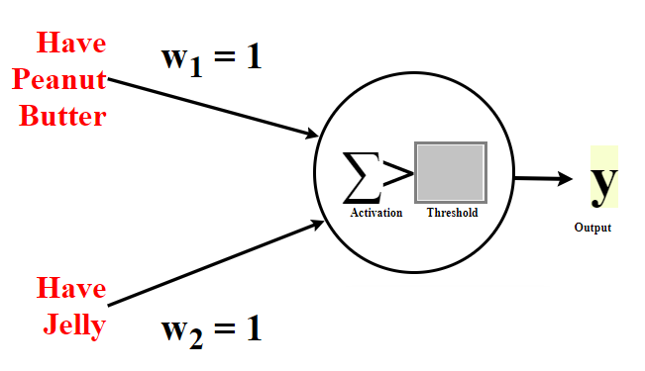

Neuron Sandbox Problem #3: Should you wear boots today? You should wear boots when it is either raining or snowing.

INPUTS |  | Compute weighted input 1: | Compute weighted input 2: | Activation: | Do we want the activation to be greater than the threshold?  This answer should be based on the desired output. | Determine the threshold:  What decimal number is greater than your Ns but less than your Ys? | Is activation greater than threshold?  If the answer doesn’t match the 1 or 0 in the desired output, change your threshold | Desired Output
Input₁  0 - Not raining  1 - Raining | Input₂  0 - Not snowing  1 - Snowing | W₁ = 1  Input₁ x W₁ = __ | W₂ = 1  Input₂ x W₂ = __ | Sum of weighted Inputs 1 & 2 | (Y or N) | Threshold | Activation > Threshold  Write 0 for no and 1 for yes. | 0 - no  1 - yes
___ | __ | __ x 1 = __ | __ x 1 = __ | __ | __ | __ | __ | __
__ | __ | __ x 1 =___ | __ x 1 = __ | __ | __ | __ | __ | __
__ | __ | __ x 1 =___ | __ x 1 =___ | __ | __ | __ | __ | __
__ | __ | __ x 1 =___ | __ x 1 =___ | __ | __ | __ | __ | __
B |  | C |  | D | E | F | G | A

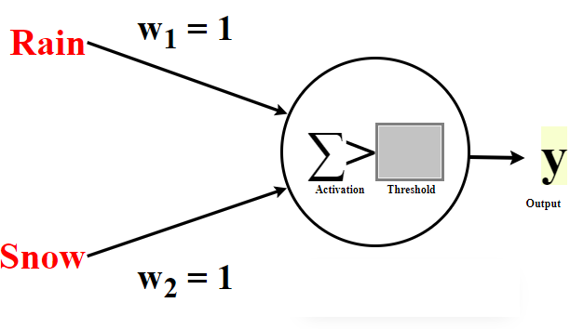

Neuron Sandbox Problem #4:Should I play outside? I would play outside either if I need exercise or if it's sunny.

INPUTS |  | Compute weighted input 1: | Compute weighted input 2: | Activation: | Do we want the activation to be greater than the threshold?  This answer should be based on the desired output. | Determine the threshold:  What decimal number is greater than your Ns but less than your Ys? | Is activation greater than threshold?  If the answer doesn’t match the 1 or 0 in the desired output, change your threshold | Desired Output
Input₁  0 - Don’t Need Exercise  1 - Need Exercise | Input₂  0 - Not Sunny  1 - Is sunny | W₁ = ?  Input₁ x W₁ = __ | W₂ = 1  Input₂ x W₂ = __ | Sum of weighted Inputs 1 & 2 | (Y or N) | Threshold | Activation > Threshold  Write 0 for no and 1 for yes. | 0 - no  1 - yes
___ | __ | __ x __= __ | __ x 1 = __ | __ | __ | _0.5_ | __ | __
__ | __ | __ x __ =___ | __ x 1 = __ | __ | __ | _0.5_ | __ | __
__ | __ | __ x __ =___ | __ x 1 = ___ | __ | __ | _0.5_ | __ | __
__ | __ | __ x __ =___ | __ x 1 = ___ | __ | __ | _0.5_ | __ | __
B |  | G |  | F | E | D | C | A

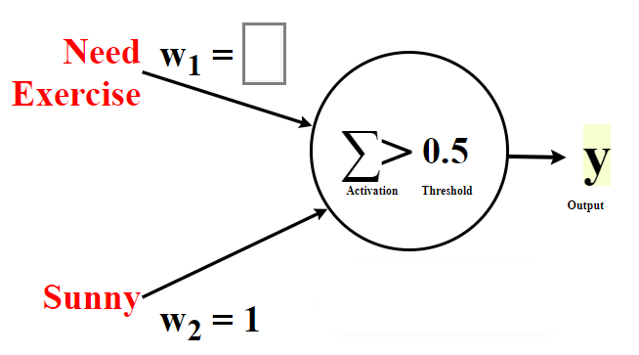

Neuron Sandbox Problem #6:John is planning a picnic with his friends. He wonders if today is a good day for a picnic. It is a good day for a picnic if it is sunny outside and if his friends are available today.

INPUTS |  | Compute weighted input 1: | Compute weighted input 2: | Activation: | Do we want the activation to be greater than the threshold?  This answer should be based on the desired output. | Determine the threshold:  What decimal number is greater than your Ns but less than your Ys? | Is activation greater than threshold?  If the answer doesn’t match the 1 or 0 in the desired output, change your threshold | Desired Output
Input₁  0 - Not Sunny  1 - Sunny | Input₂  0 - Friends not available  1 - Friends available | W₁ = 2  Input₁ x W₁ = __ | W₂ = 2  Input₂ x W₂ = __ | Sum of weighted Inputs 1 & 2 | (Y or N) | Threshold | Activation > Threshold  Write 0 for no and 1 for yes. | 0 - no  1 - yes
___ | __ | __ x 2= __ | __ x 2 = __ | __ | __ | __ | __ | __
__ | __ | __ x 2 =___ | __ x 2 = __ | __ | __ | __ | __ | __
__ | __ | __ x 2 =___ | __ x 2 =___ | __ | __ | __ | __ | __
__ | __ | __ x 2 =___ | __ x 2 =___ | __ | __ | __ | __ | __
B |  | C |  | D | E | F | G | A

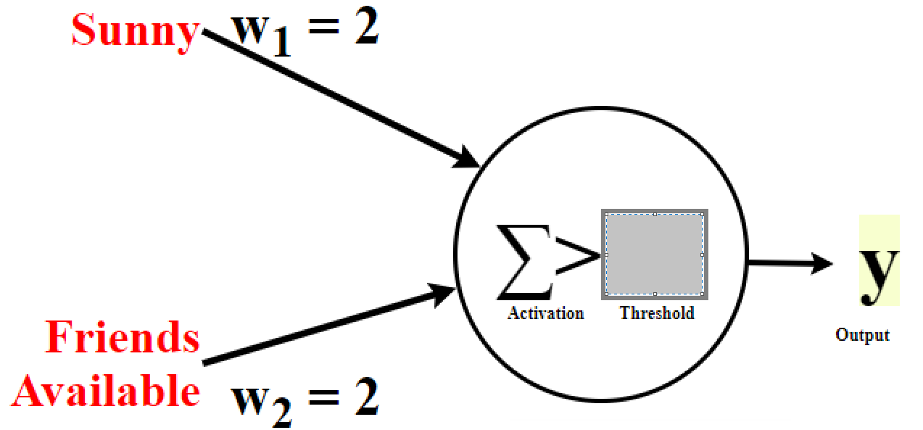

Neuron Sandbox Challenge Problem #9: Can you make a peanut butter and jelly sandwich? You need both peanut butter and jelly. (Hint: This is a different problem then the earlier problem.)
INPUTS |  | Compute weighted input 1: | Compute weighted input 2: | Activation: | Do we want the activation to be greater than the threshold?  This answer should be based on the desired output. | Determine the threshold:  What decimal number is greater than your Ns but less than your Ys? | Is activation greater than threshold?  If the answer doesn’t match the 1 or 0 in the desired output, change your threshold | Desired Output
Input₁  0 - Not out of Peanut Butter  1 - Out of Peanut Butter | Input₂  0 - Not out of Jelly  1 - Out of Jelly | W₁ = -1  Input₁ x W₁ = __ | W₂ = -1  Input₂ x W₂ = __ | Sum of weighted Inputs 1 & 2 | (Y or N) | Threshold | Activation > Threshold  Write 0 for no and 1 for yes. | 0 - no  1 - yes
___ | __ | __ x -1 = __ | __ x -1 = __ | __ | __ | __ | __ | __
__ | __ | __ x -1 =___ | __ x -1 = __ | __ | __ | __ | __ | __
__ | __ | __ x -1 =___ | __ x -1 =___ | __ | __ | __ | __ | __
__ | __ | __ x -1 =___ | __ x -1 =___ | __ | __ | __ | __ | __
B |  | C |  | D | E | F | G | A

